**1 - Resources & Support** (<https://magento.abmgood.com/support/index/index/>):



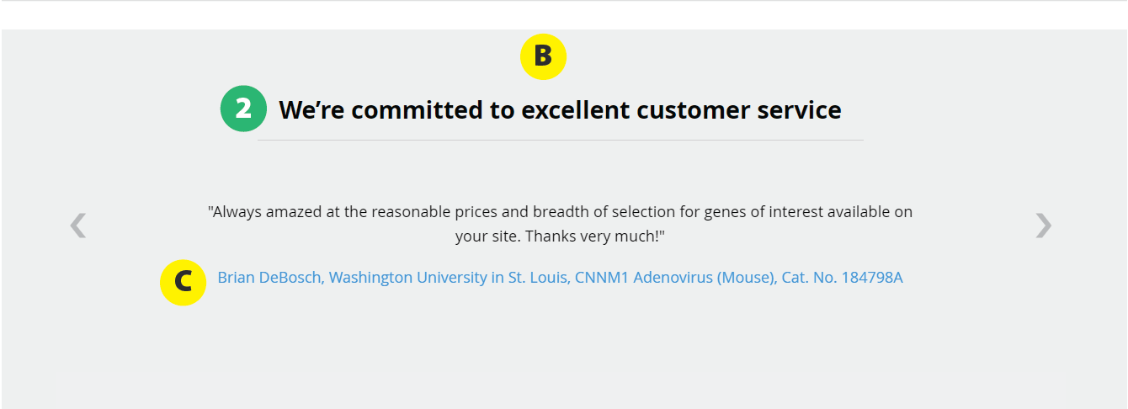

**Follow CSS style on Free Samples page** (<https://magento.abmgood.com/promotions/index/samples>):

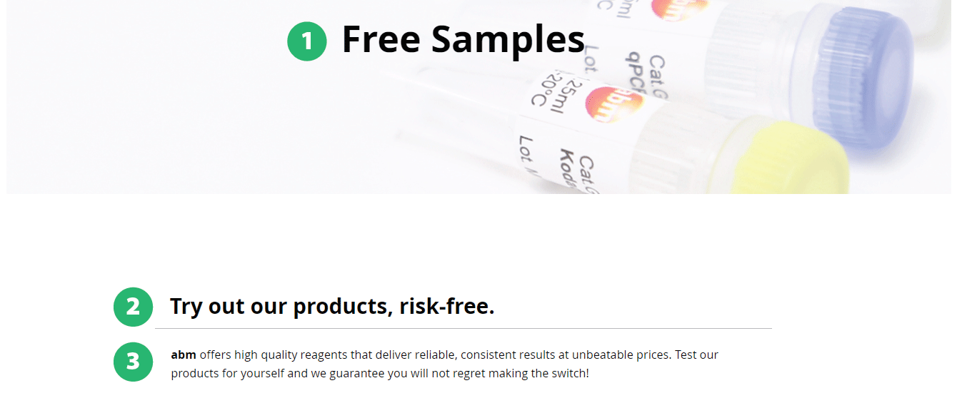

Notes:

* Match CSS styles (line height, font size, and font weight) for the text labelled with the same numbers
* **A:** 
  + Increase border thickness to 3px
  + Increase size of the icon inside the circle to 4.5em
  + Add 10px space after the circle (between the circle and the orange text)
  + Orange text link
    - color: #ff734d on hover
  + Increase space between the black text in the 4 columns
    - I notice that there’s currently 10px of padding left and right for that text
    - Can you increase it to 25px left and right?
* **B:**
  + Add 20px of space in this area (increase space on top of the heading)
* **C:**
  + Blue text: Match font-size (change px to em) and line-height with the black text above it